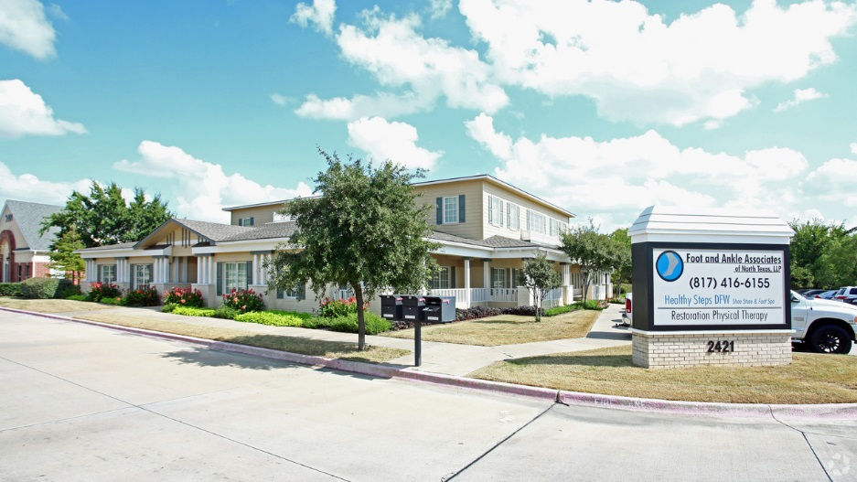

Property Overview

For Sale : Call for pricing

Center Site – 12,327 sq ft

Property Type: Medical Office / Office  
Building Class: A

**2421 Ira E Woods Ave**

**Professional Medical Building**

**Location  
Highlights**

* 12,327 SF of Medical/Professional Office Space For Sale
* Located Less than 1 Mile from Baylor Scott and White Medical Center in Grapevine
* Ira E Woods is a Major Thoroughfare to 121N and State Hwy. 114 with Traffic Counts Exceeding

30,000+ CPD

* Great Visibility on Ira E Woods (Hwy 26)
* Call for pricing
* Current tenants include : Foot and Ankle Associates, Healthy Steps DFW, Restoration Physical Therapy
* Capture the Southlake & Grapevine Market, One of the Strongest Demographic Areas in the Country





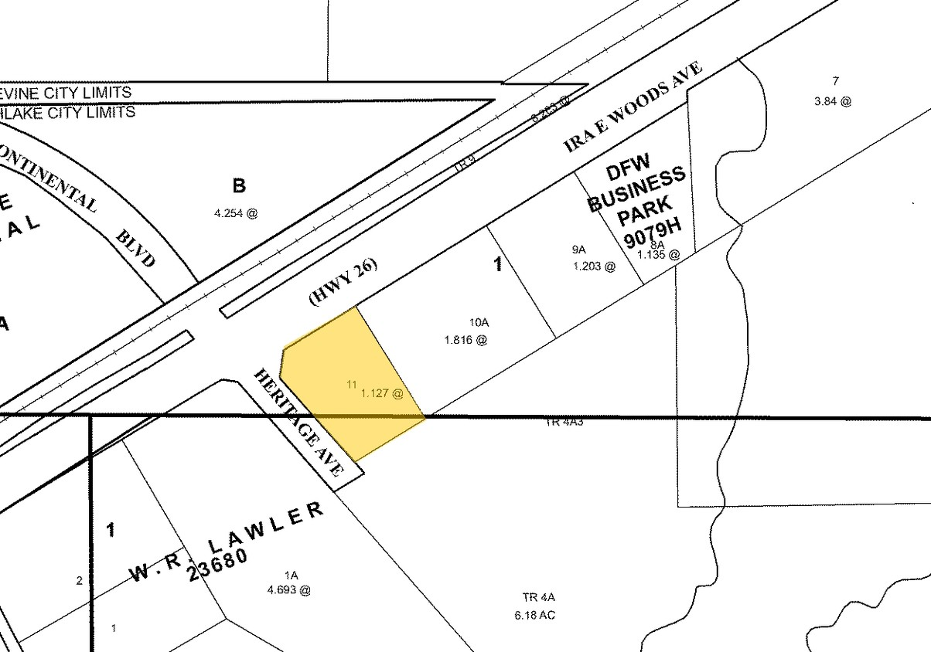

Map

Site Plan